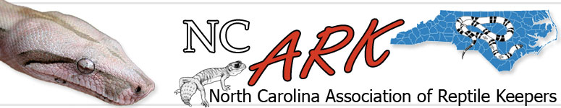
USFWS Proposal Would Ban Boas & Pythons
Feds Move To Ban Pythons & Boas
Saturday, February 2. 2008
Ball Python - photo © ronald durst
The U.S. Fish & Wildlife Service has made a significant move towards banning the importation and interstate transport of Boa Constrictors and Pythons in the United States. Quietly published in the Federal Register, the agency is accepting public comments until April 30th. If enacted this will devastate an already hard hit industry, dealing a fatal death blow to a large number of businesses dependent on this segment of the industry and drying up the supply of these pets to pet owners across the United States. Noted herpetologist, author, former zookeeper, and one of the leading private researchers and breeders of pythons in the United States, David Barker, had this to say...
This is the formal notification and request for public comments regarding the intention of USF&W Service to place ALL snakes in the genera Boa, Python, and Eunectes on the Injurious Wildlife List of the Lacey Act.
If enacted as regulation, this will ban the importation of said snakes into the USA , and ban all interstate transportation of said snakes.
There is a request made for public input and we feel it will be very important that all keepers with an interest in boas and pythons make written response before 30 April.
This is VERY important. Don’t take this lightly.
Once the importation and inter-state transport has been banned, there will be a rapid exodus of breeders of these species, and eventually they will disappear from the marketplace along with a significant number of businesses and jobs. Pet owners will feel the pinch as dry goods suppliers and caging manufacturers stop producing products for that segment of the hobby, and eventually it will be impossible to obtain a new pet boa or python.
To review the USF & W Service proposal, please look at the following document. http://kingsnake.com/FWSReview.pdf
Please note that this is a .pdf file and requires Adobe Acrobat to open and read it.
The designation of Boas and Pythons as "injurious wildlife" carries a lot of baggage. It means that not only would there be a ban on import and interstate transport, but a ban on ownership... much like the mongoose. I will be putting out more annalysis and a plan of action soon. Spread this info to everyone you know!
Andrew

ncark.org | Unsubscribe | Developed by Site Control 24/7

